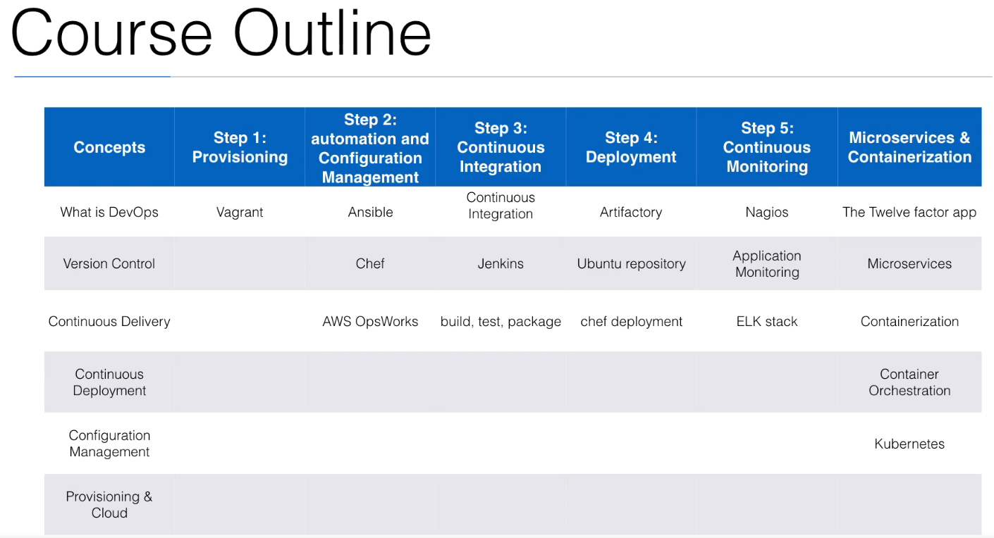

* Excel in software delivery and apply the same methodologies
* Make familiar using tools
  + Chef
  + Ansible
  + Jenkins
  + Docker, Kubernetes

**DevOps Course Resources**

Copy paste this to a text document on your local drive. You will need these URLs during the lectures.

**URLs**

* github: [www.github.com](http://www.github.com/)
* chef: [www.chef.io](http://www.chef.io/)
* ansible: [www.ansible.com](http://www.ansible.com/)
* Jenkins: <https://jenkins-ci.org/>

**GIT repositories used**

* <https://github.com/wardviaene/ansible-demo>
* <https://github.com/wardviaene/chef-demo>
* <https://github.com/wardviaene/play-demo>
* <https://github.com/wardviaene/docker-demo>

**Instructions**

* AWS Account: [https://github.com/wardviaene/ansible-demo/raw/mas...](https://github.com/wardviaene/ansible-demo/raw/master/misc/AWSAccountCreation.pdf)

**Forum & Support**

* Facebook: <https://www.facebook.com/groups/840062592768074/>

What is DevOps?

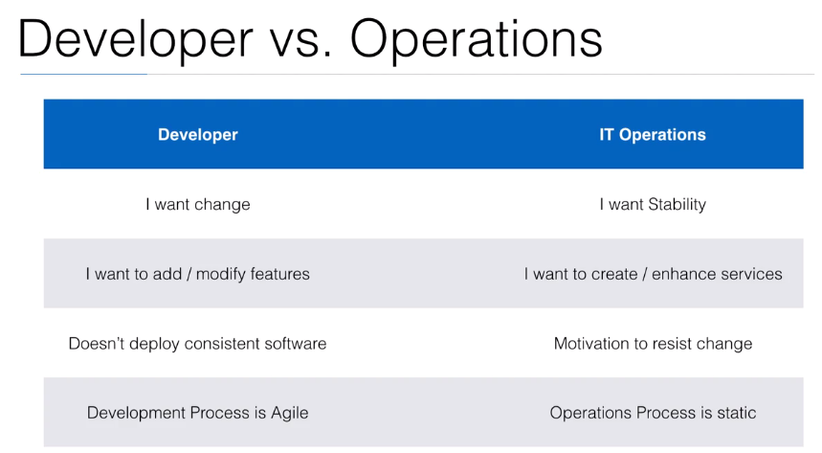

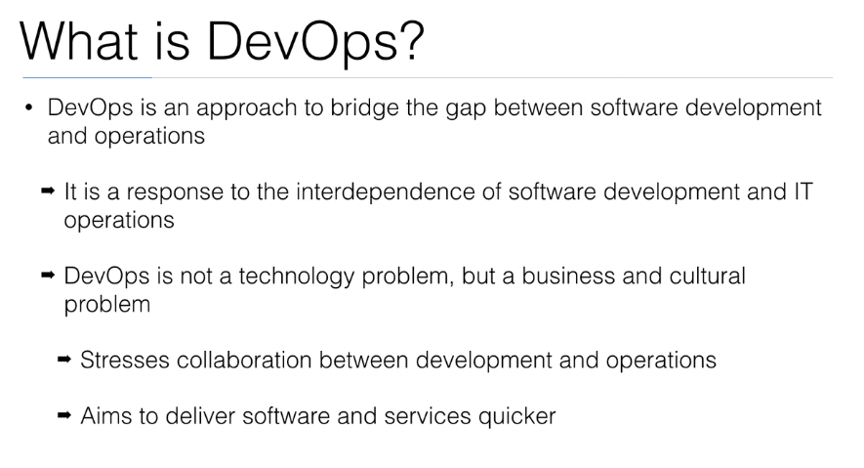

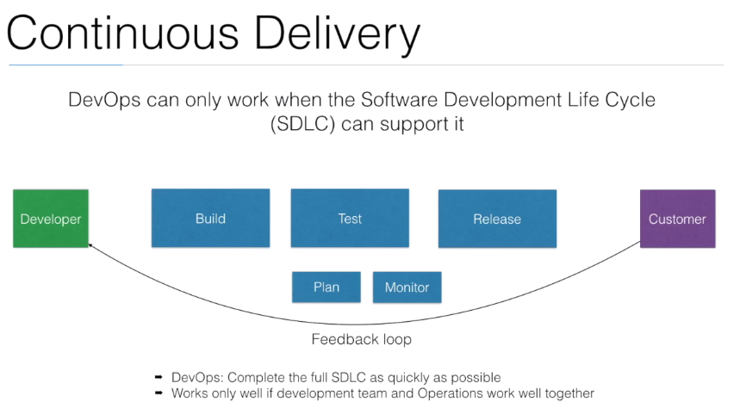

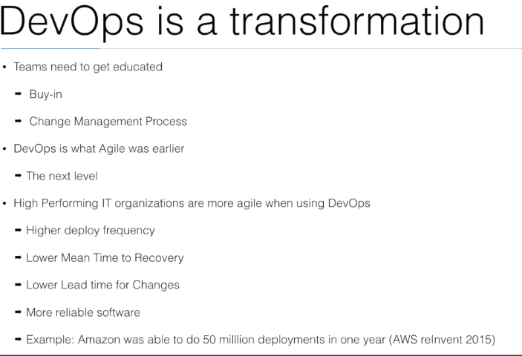

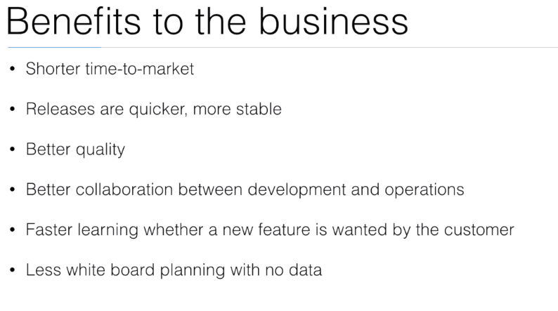

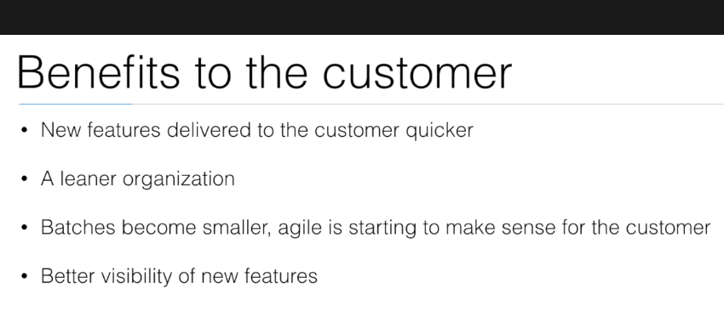

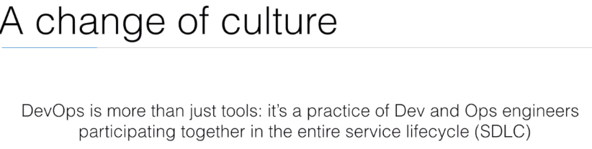

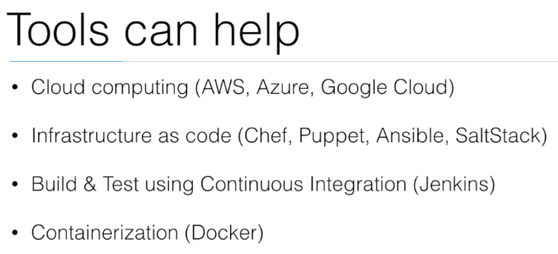

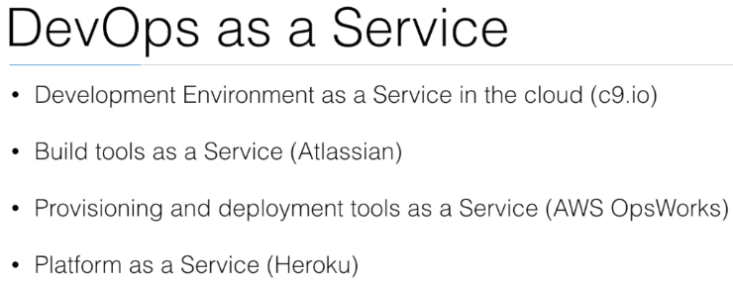

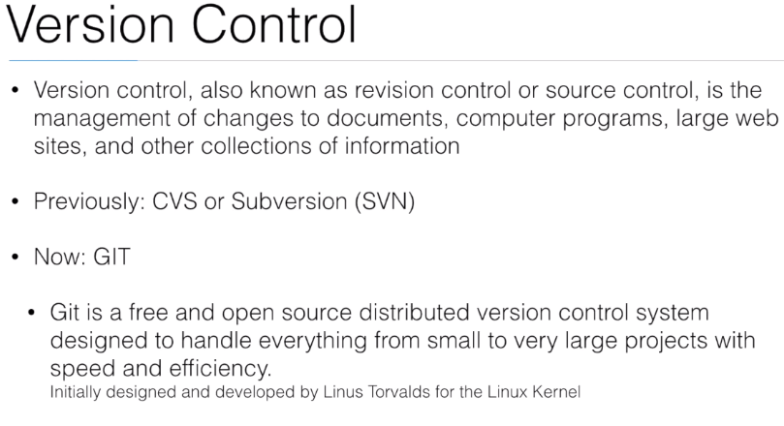

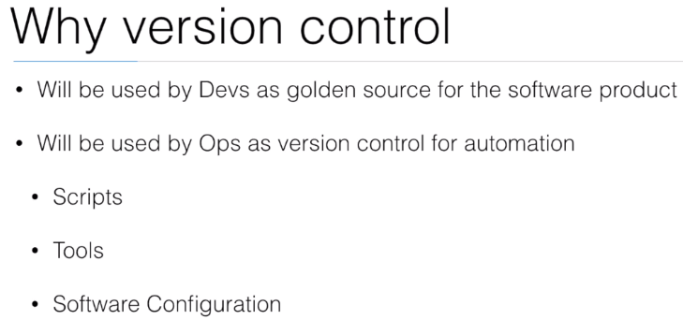

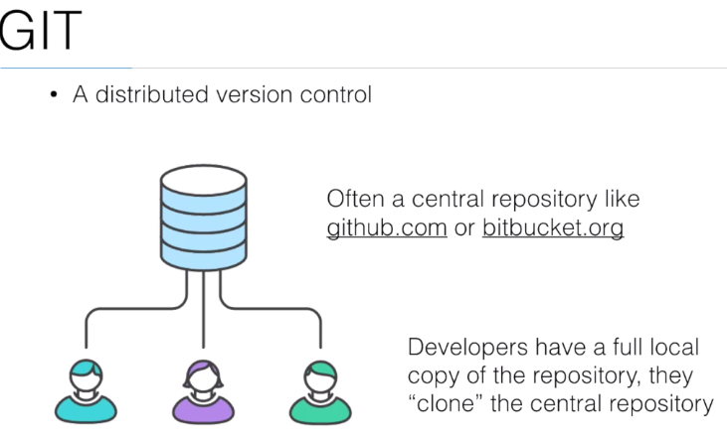

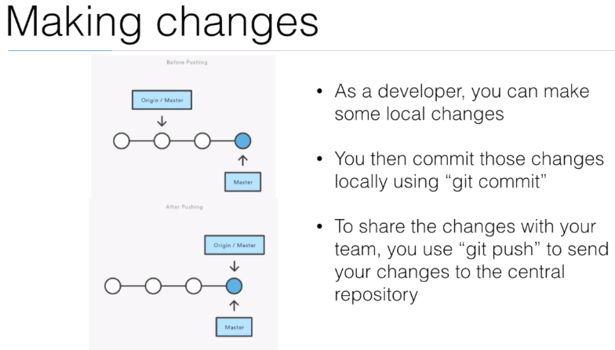

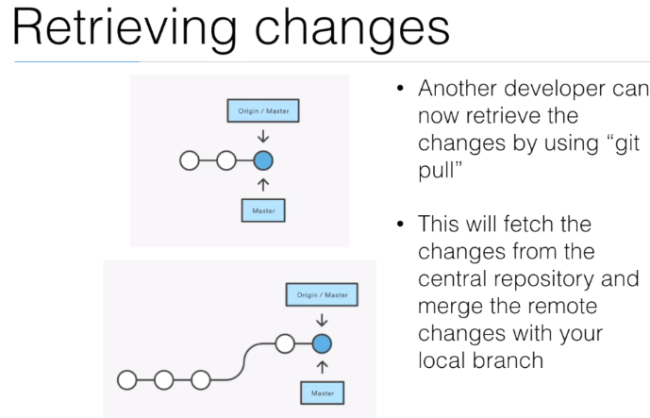

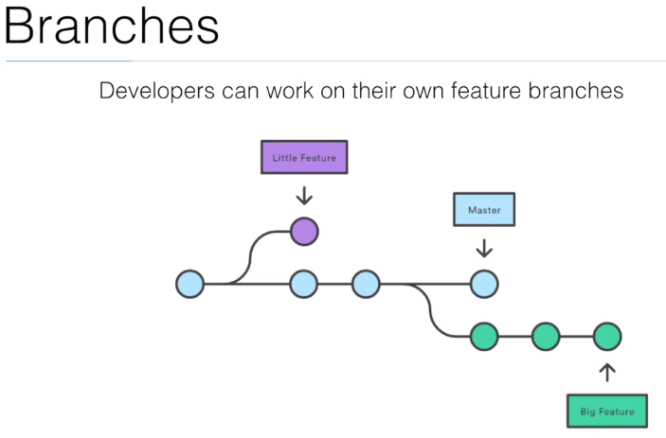

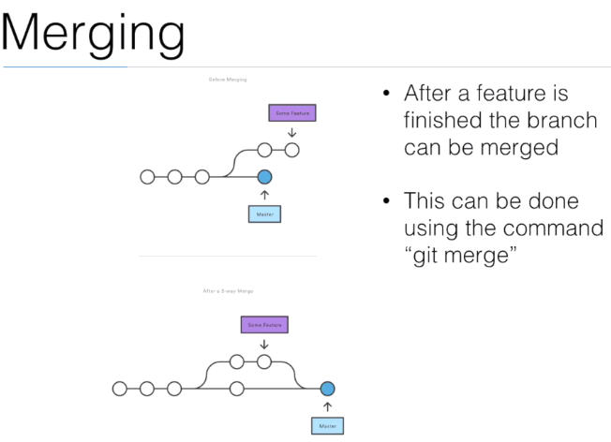

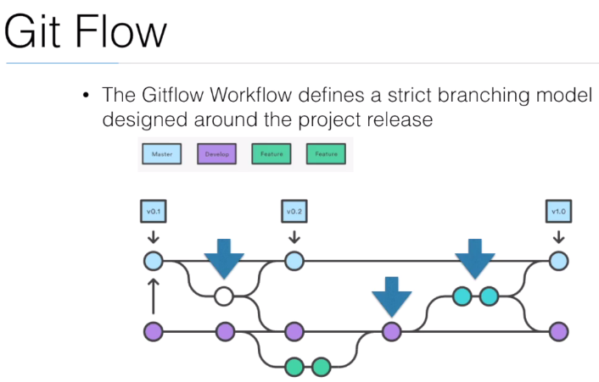

**GIT Resources**

**Sudo apt-get install git**

**Creating a new repository**

mkdir project

cd project

git init

git remote add origin git@github.com:yourlogin/your-repo.git

git add .

git commit -am “new repository”

git push -u origin master

**Cloning existing repository**

git clone https://github.com/username/your-repo.git

**Creating branch**

git checkout -b feature-1

# you are now in a branch, you can edit and create new files

git add .

git commit -am “new feature”

**Merging branch to master**

git checkout master

git merge feature-1

git push

**Deleting branch**

git branch -d feature-x

**List all branches**

git branch -a

**Switch branch**

git checkout feature-x

**Switch to master branch**

git checkout master

**Listing Remote repositories**

git remote -v

**Replacing remote repository**

# in case your remote repository changes, or you want to switch from HTTPS->SSH or SSH->HTTPS

git remote remove origin

git remote add origin [git@github.com](mailto:git@github.com):yourlogin/your-repo.git

**More resources**

git commands: <https://www.atlassian.com/git/tutorials/comparing-workflows/>

git flow: <http://danielkummer.github.io/git-flow-cheatsheet/>

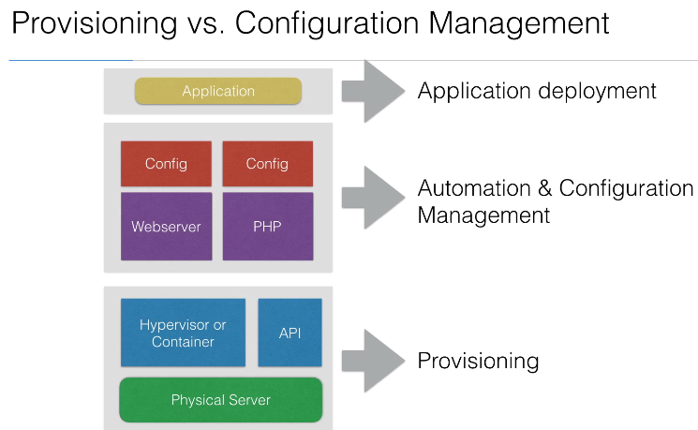

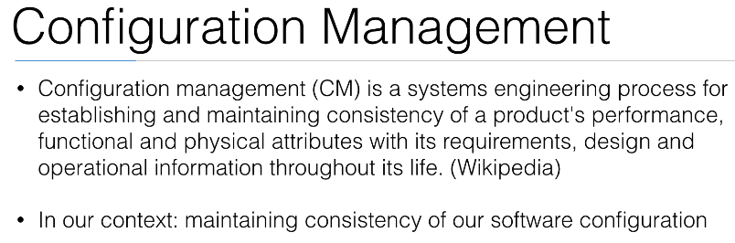

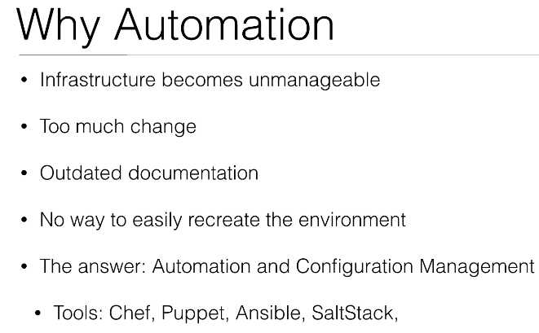

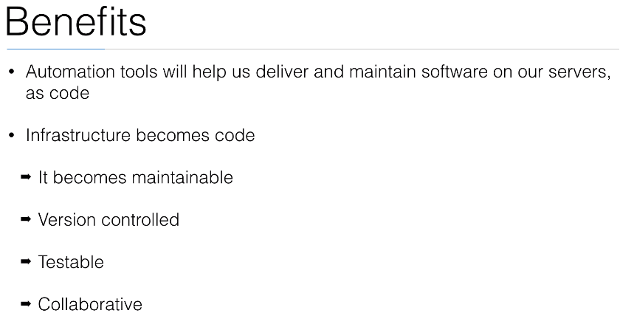

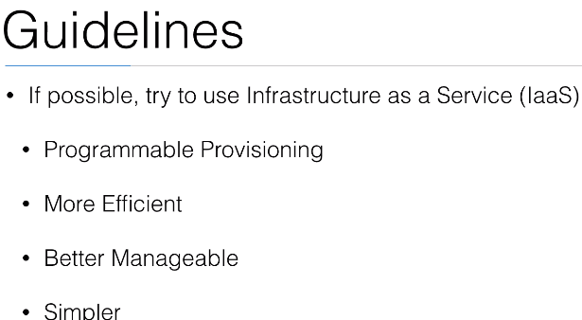

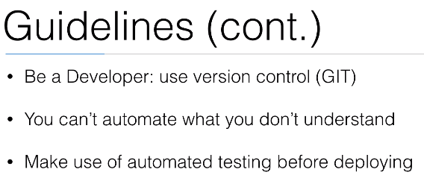

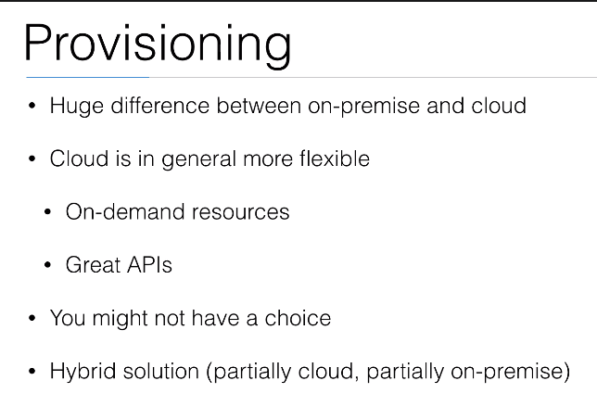

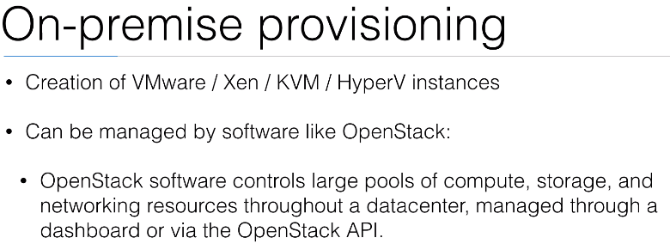

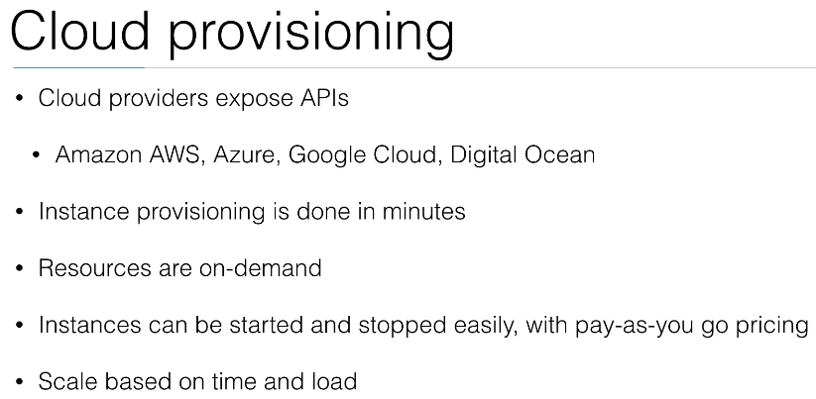

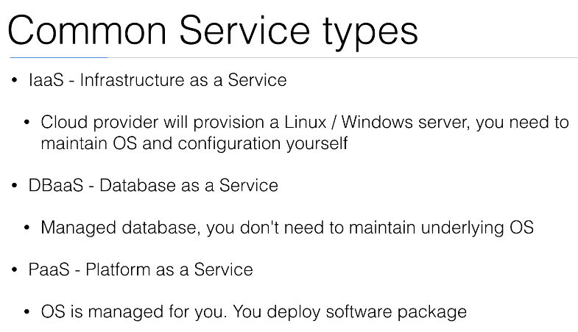

Plan and Monitor

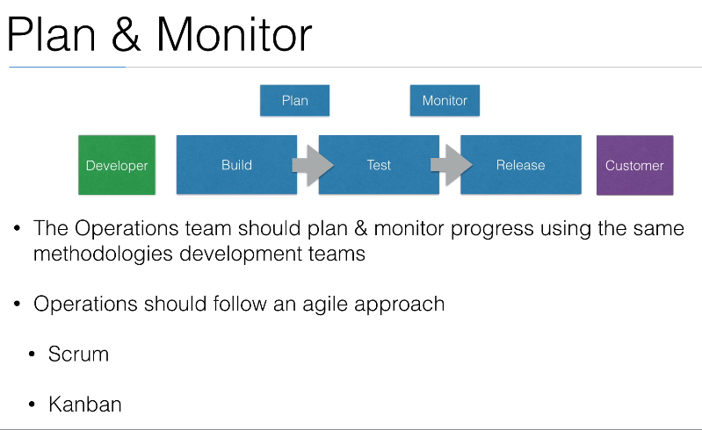

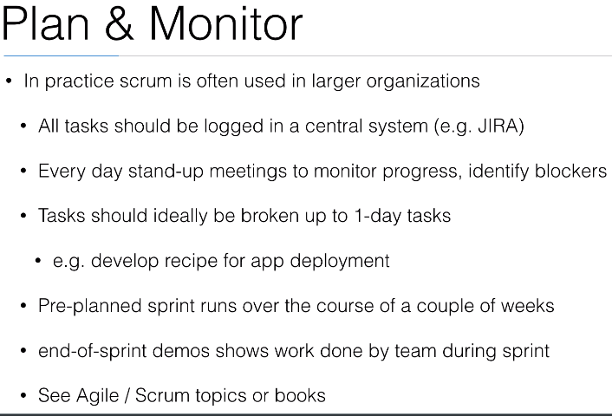

**Provisioning**

